Hotel Renovations Announcement for Guests

Subject Line: We’re building your future stay! *Important information regarding your upcoming stay with us*

Dear Valued Guest,

We’re looking forward to your upcoming stay with us at the **insert name of hotel** in **insert hotel city & state**!

During your stay, you may notice that we are making some improvements to our hotel including **list your renovations provided by Amerail Systems**.

These renovations are for you, our valued guest, so your future stay with us will be even better.

Please be assured that we have taken every precaution to make sure your stay is not affected by our renovations.

We have worked closely with our renovation company, **Amerail Systems** who are experienced hotel renovators dedicated to making sure our guests remain happy throughout their stay.

As always, our dedicated staff is here and will be there for you if you have any questions or concerns.

We can’t wait for you to arrive & book your next stay with us at the **insert name of hotel**!

Sincerely,

The **insert hotel name** **insert management** & staff

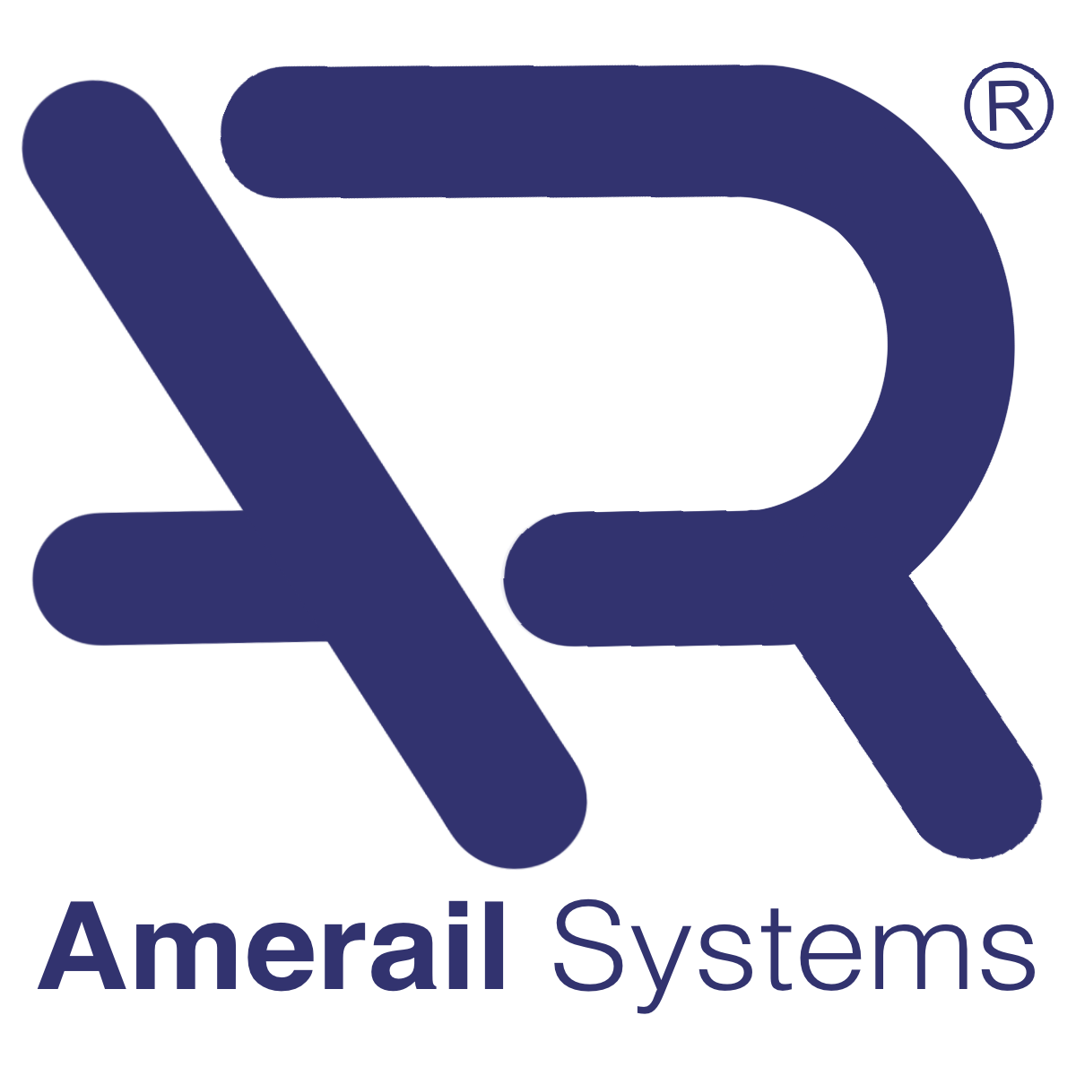**replace Amerail Systems logo with Hotel logo**

